**PRESS RELEASE**

**COMMUNICATIONS AND MEDIA TEAM OF THE 2023 ASEAN SUMMIT**

**No.83/SP/TKM-ASEAN2023/ENG/5/2023**

**Observer Appreciates TNI-Polri Solidity in Securing the 42nd ASEAN Summit**

**Jakarta, 12 May 2023** - Defense and security observer Ngasiman Djoyonegoro expressed appreciation to the solidity of the Indonesian National Armed Forces (TNI) and National Police (Polri) in ensuring the security of the 42nd ASEAN Summit in Labuan Bajo, East Nusa Tenggara (NTT).

"I appreciate the government's success in organizing the ASEAN Summit, specifically for the TNI-Polri who have made thorough preparation for security amid the issue of solidity and synergy between the TNI-Polri which is being tested," said Ngasiman Djoyonegoro or Simon in a statement in Jakarta, Friday, 12 May.

According to him, the 42nd ASEAN Summit in Labuan Bajo has run smoothly and resulted in many agreements.

Simon explained that ASEAN Member States agreed on resolutions related to trafficking in person and Myanmar conflict.

In his opinion, these two issues must be resolved in the context of humanity and law enforcement.

"The leaders also agreed on a future vision to be part of the supply chain in realizing electric vehicles. ASEAN has confirmed its role in the global renewable energy ecosystem," he said.

According to him, the 42nd ASEAN Summit 2023 is very serious in discussing issues that arise among Member States, while at the same time affirming ASEAN's position in the geopolitical arena.

Simon explained that issues such as the South China Sea, the Ukrainian-Russian war, the Israeli-Palestinian conflict are of serious concerns for ASEAN leaders because the Southeast Asian region is one of the determinants of geopolitical movements.

"Although ASEAN Member States are not involved in the Russia-Ukraine War and the Israeli-Palestinian Conflict, countries in the region are affected by these conflicts, both economically and politically," he said.

Simon, who is also Rector of the Al-Kamal Jakarta Institute of Science and Technology said that ASEAN countries has the potential and is very strategic to become proxy area and new battlefields by blocs of countries in conflict.

According to him, especially since Indonesia is an archipelagic country, many weapons can be tested in a maritime country like Indonesia.

Simon explained that one of the most crucial things that could divide ASEAN is related to the South China Sea, China's intention to claim the area has the potential to divide ASEAN members by using its influence in the Indo-China region.

"Fortunately, this issue has been discussed seriously at the Summit so that there are diplomatic anticipation efforts that have been scheduled," he said.

Apart from that, he also mentioned that the Declaration of Conduct (DOC) between the ASEAN Foreign Ministers and China in 2002 is the right step in the midst of growing tension in the region.

According to him, peaceful and justice efforts must be prioritized to prevent conflicts like Russia-Ukraine to occur in the region.

"The success of the 42nd ASEAN Summit under Indonesia's chairmanship is expected to be a good start to encourage a more peaceful, just and prosperous global order," he said. Therefore, he hopes that the vision that Indonesia bring is expected to increase ASEAN's level of influence at the global level. (Priest Antara/TR/Elvira/ug/PPR)

***

For more information, please contact:

**Director General of Public Information and Communications of the Ministry of Communications and Informatics – Usman Kansong (0816785320).**

Get more information at <http://asean2023.id>, <https://infopublik.id/kategori/asean-2023>, and <https://indonesia.go.id/kategori/ragam-asean-2023>

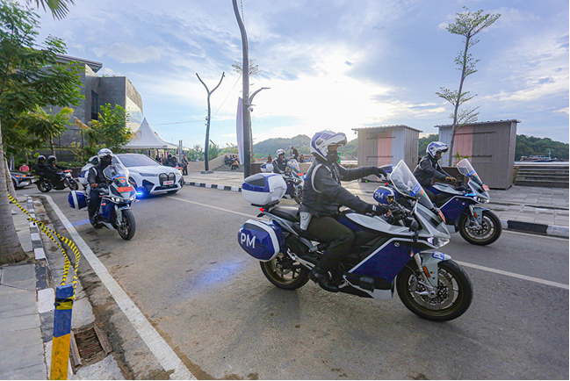

A number of security officers drove electric vehicles to secure the 42nd ASEAN Summit 2023 in Labuan Bajo, West Manggarai, East Nusa Tenggara (NTT), Thursday, 11 May 2023. At least 200 units of electric vehicles were brought to Labuan Bajo to be used as security vehicles for delegates from ASEAN member countries and committees from Ministries and Institutions. (Infopublik/Agus Siswanto)